**GOVERNMENT OF TAMILNADU**

**Naan Mudhalvan – Project Based Experiential Learning**

Project Report on

**INDIA’S AGRICULTURAL CROP PRODUCTION ANALYSIS (1997-2021)**

**Submitted by**

**K.KOWSALYA : (791C49FB03312EFA3494F92E90A6C73D)**

**S.ROSINI : (F10CD5A8A91090FB5624E4C0C3118F6C)**

**R.SUNDHARAMMAL : (3DAC7B9BB2F28A1B832448ECA5E4607F)**

**P.UDHAYA : (19A93CD61C2E7E18BEC4CD9DD5124B76)**

**(TEAM ID :NM2023TMID07166 )**

**Under the guidance of**

**Dr. M. GAYATHRI M.Sc., Ph.D**

**Guest Lecturer**

**Department of Mathematics**

GOVERNMENT ARTS COLLEGE FOR WOMEN,

(Affiliated to Mother Teresa Women’s University, Kodaikanal)

Reaccredited with “C” Grade by NAAC

NILAKOTTAI-624 208

**INTRODUCTION**

**Overview**

This report delves into the captivating realm of India's agricultural cultivation, providing a comprehensive visual exploration of key aspects and trends in the agricultural sector. Through the visual representations, readers can gain valuable insights into crop production, seasonal variations, regional distribution, and overall production trends. These visualizations enable intuitive analysis, allowing stakeholders to uncover patterns, identify areas of growth or concern, and make data-driven decisions.

By harnessing the power of Tableau, this report not only presents the data in a visually appealing manner but also provides an interactive experience for readers to explore the intricacies of India's agricultural cultivation. To Extract the Insights from the data and put the data in the form of visualizations, Dashboards and Story we employed Tableau tool.

**Purpose**

The primary business requirements for this report are to visualize and analyze business expenses, provide industry-specific insights, identify cost drivers, highlight outliers, and offer interactive functionality. Stakeholders need a visual representation of expenses to compare and analyze spending patterns across different businesses and industries. The report should facilitate the identification of key cost drivers, enabling stakeholders to understand the primary factors contributing to expenses. Additionally, it should flag any outliers or anomalies for further investigation. The report should provide a user-friendly and intuitive experience that empowers stakeholders to make data-driven decisions and drive positive change in the agricultural sector.

**Problem Definition & Design Thinking**

Empathy Map

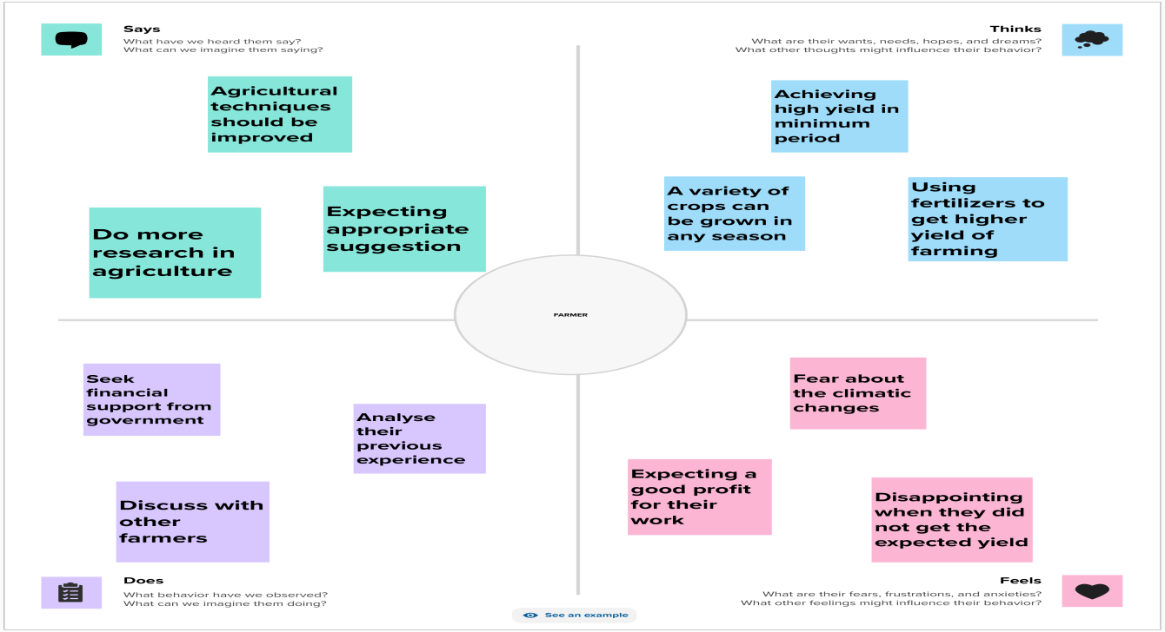

**Ideation & Brainstorming Map**

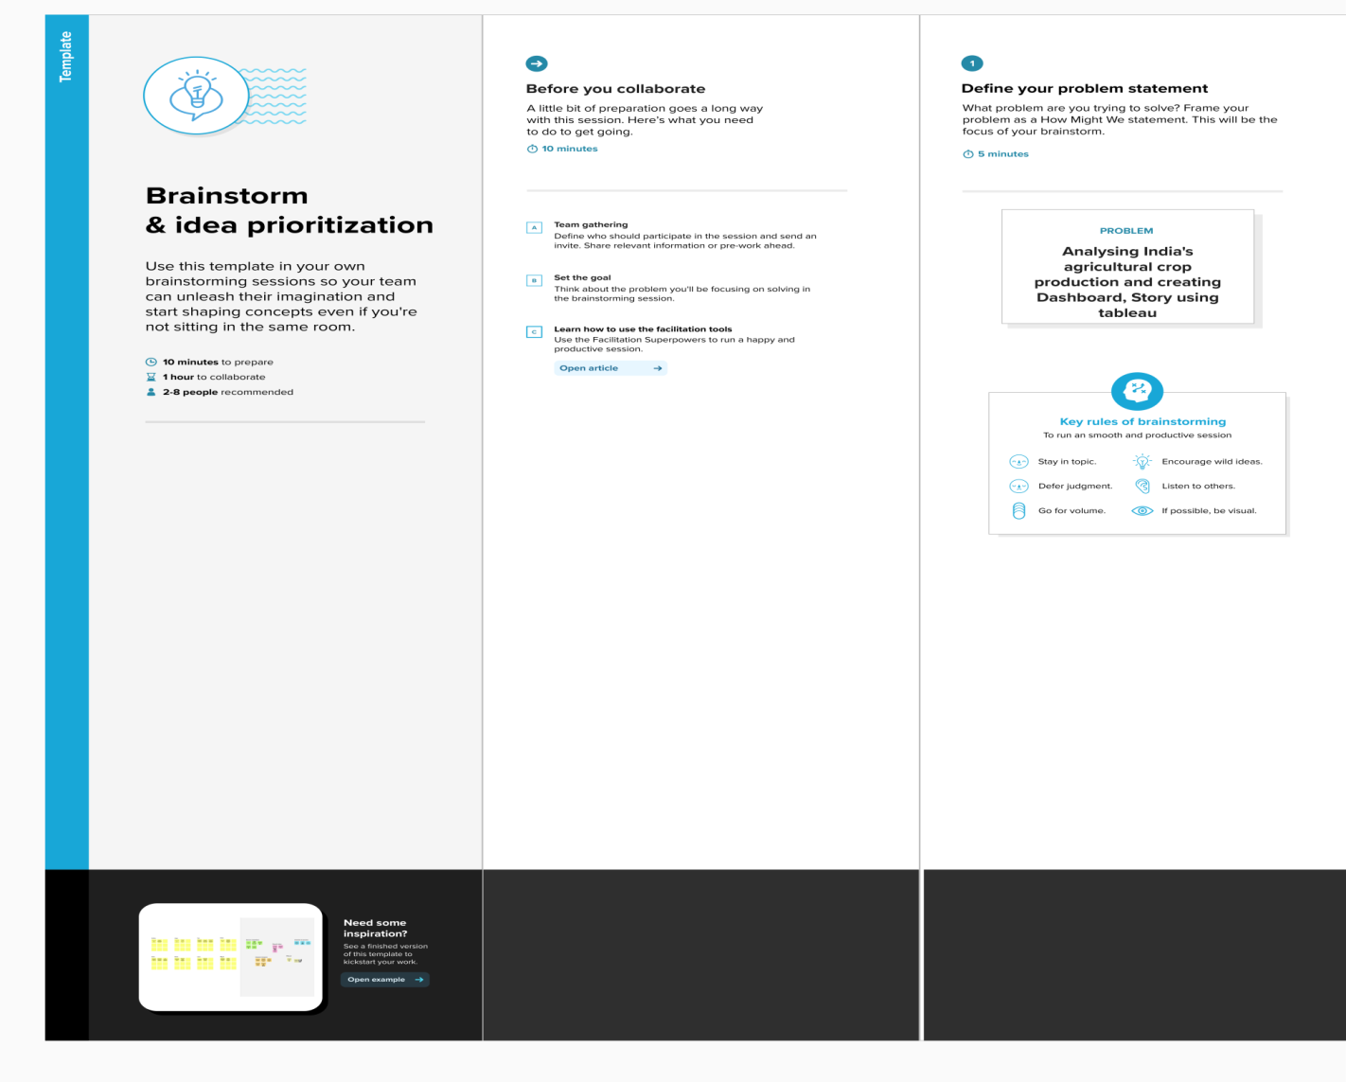

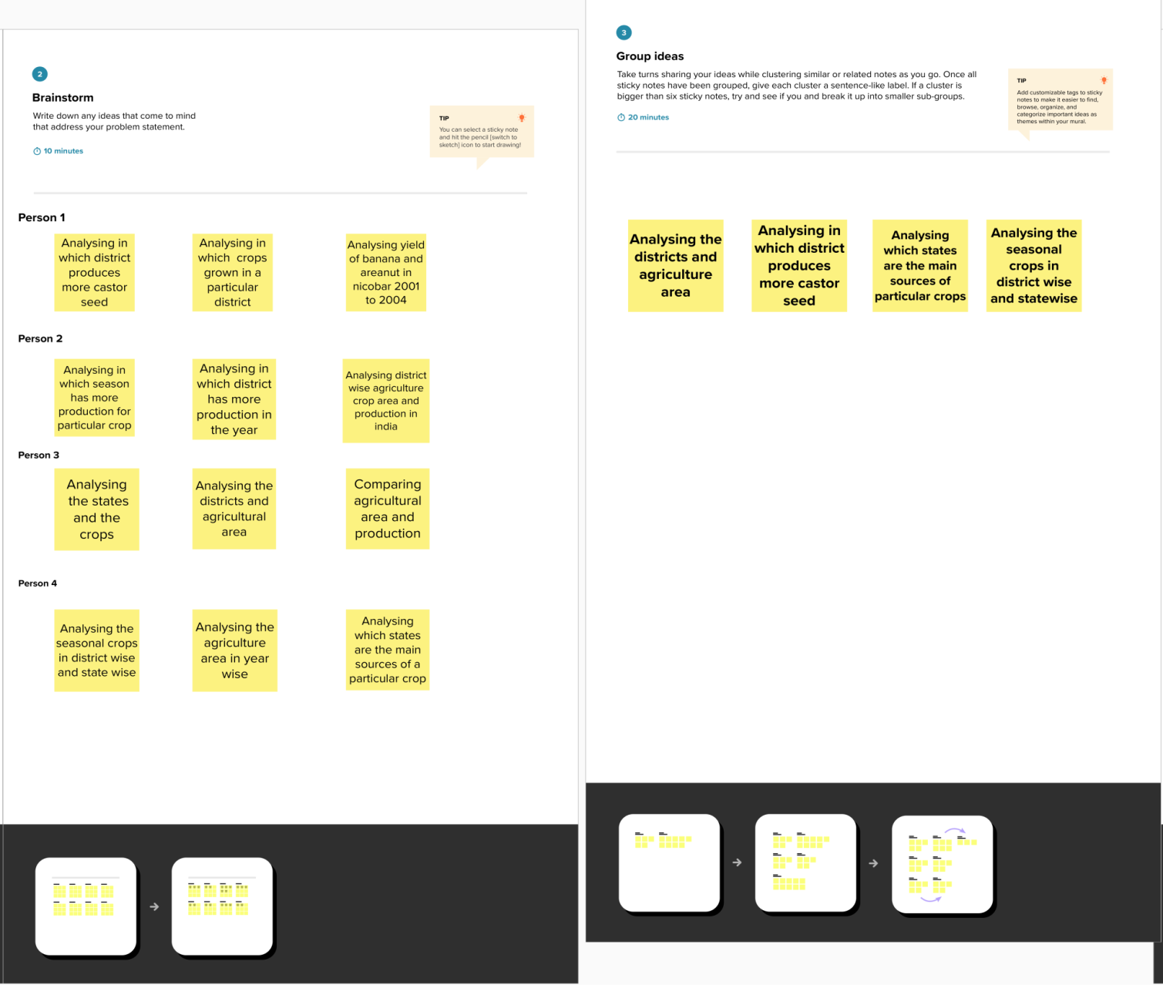

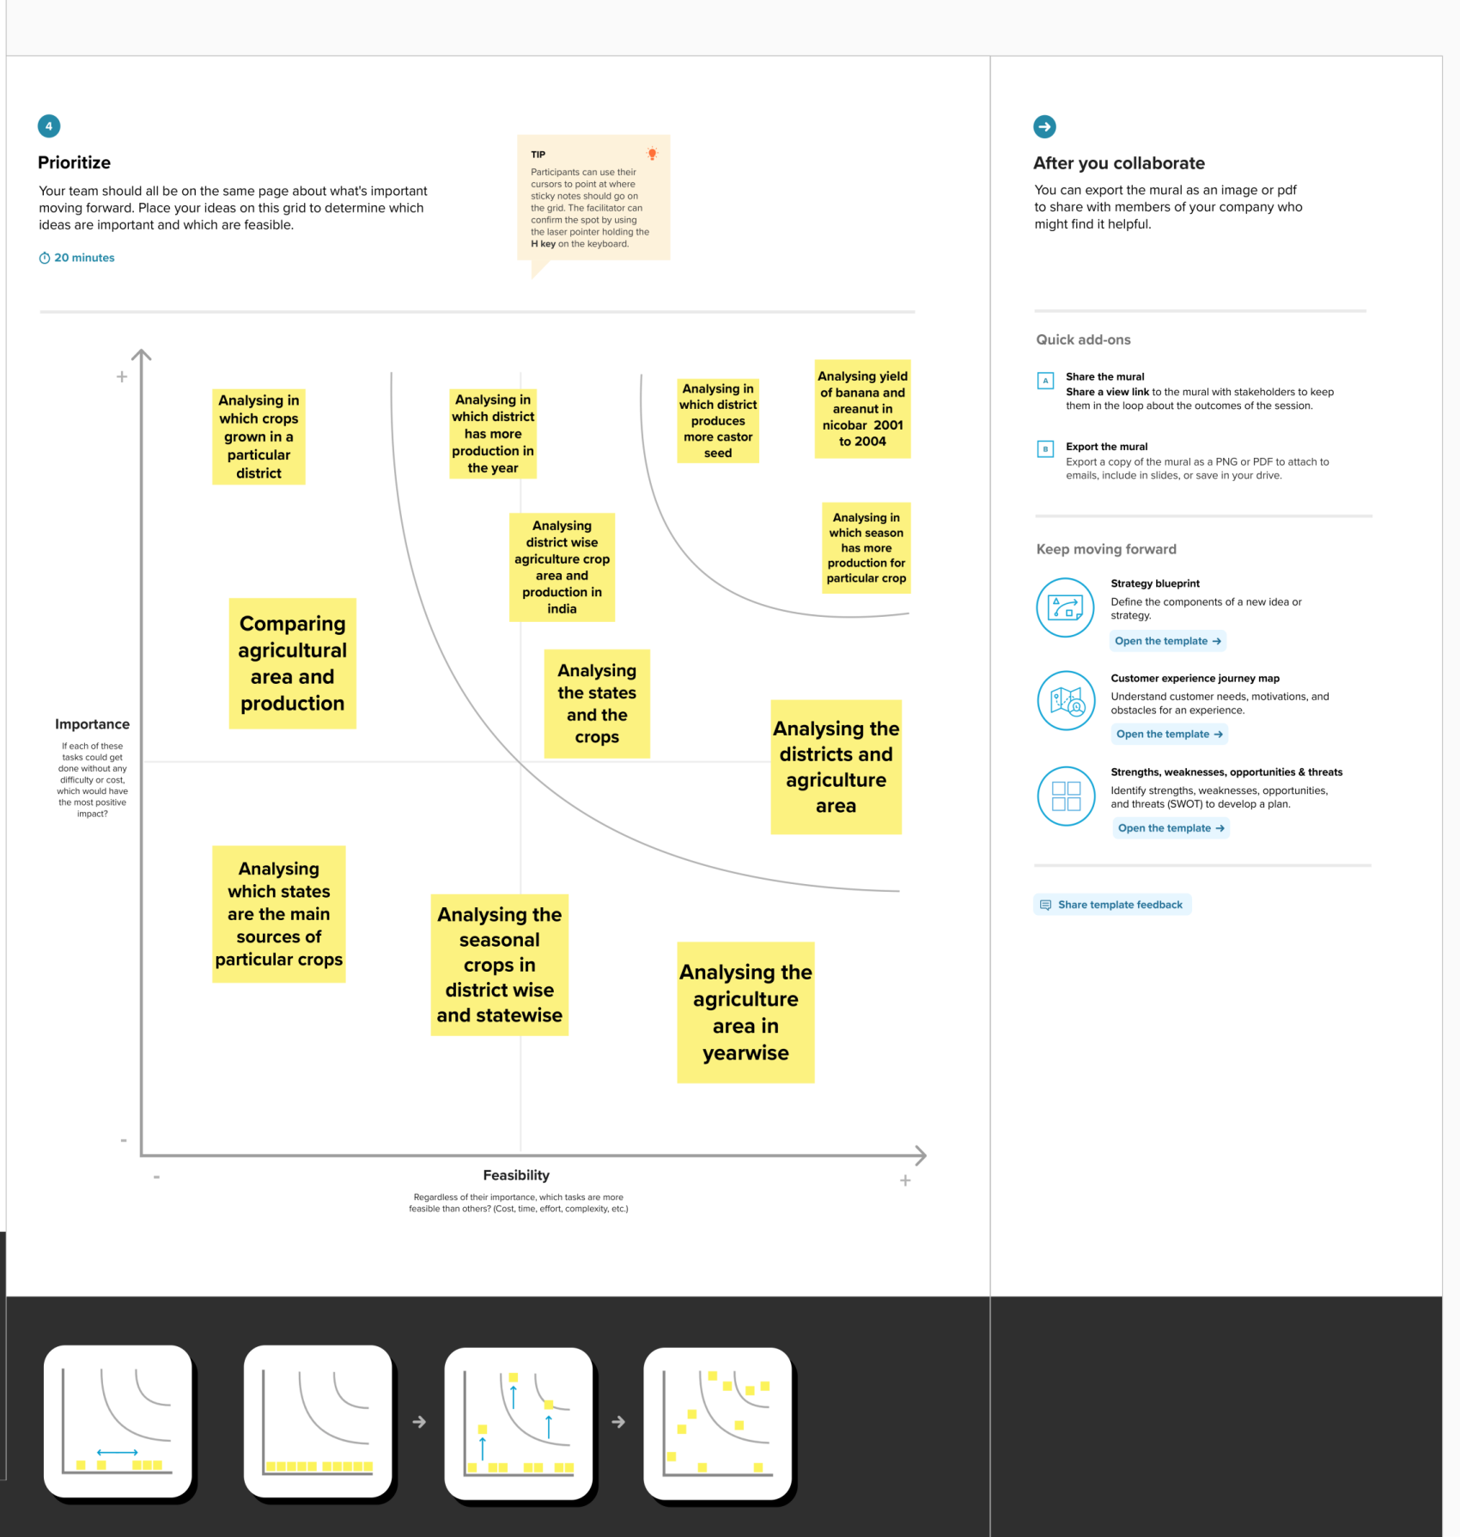

**Result**

Activity1:

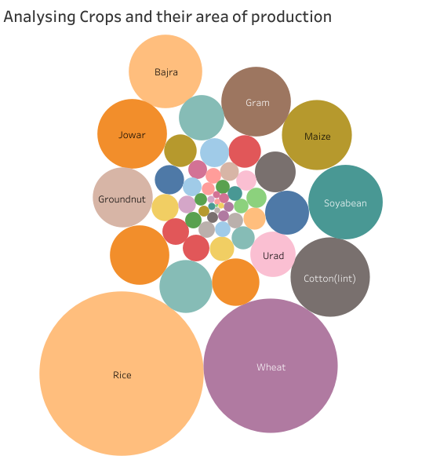

Activity2:

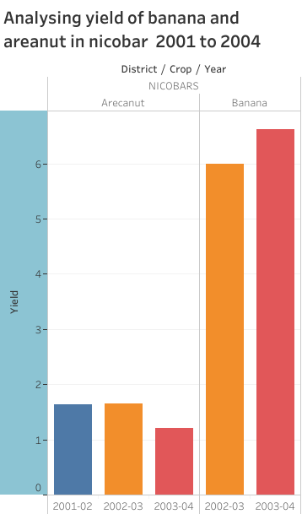

Activity3:

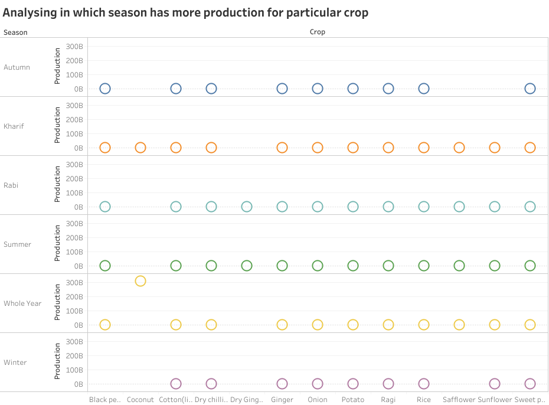

Activity 4:

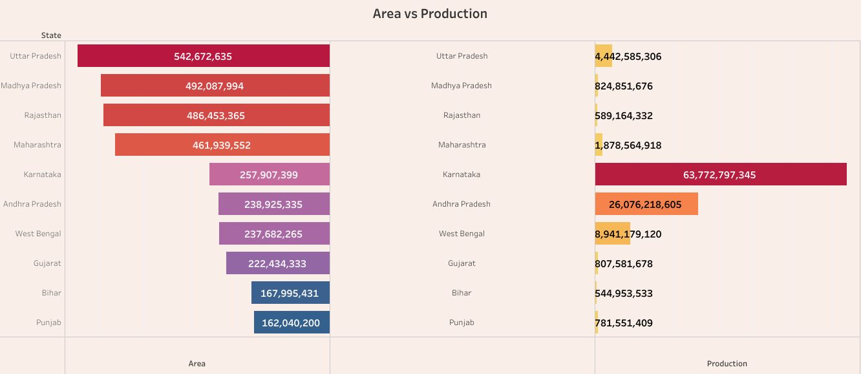

Activity 5:

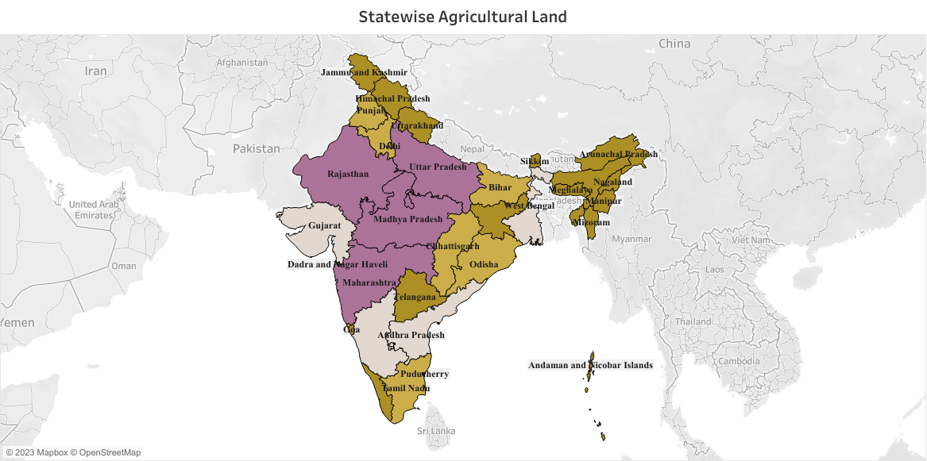

Activity 6:

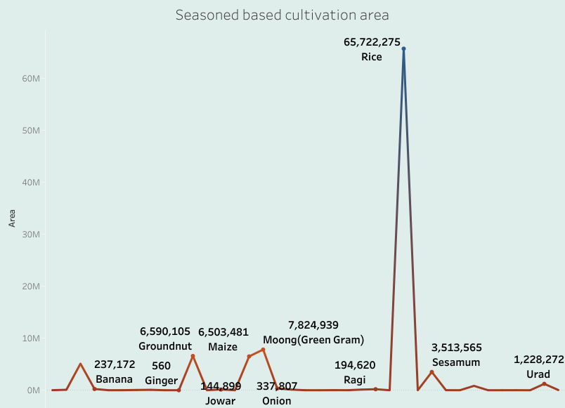

Activity 7:

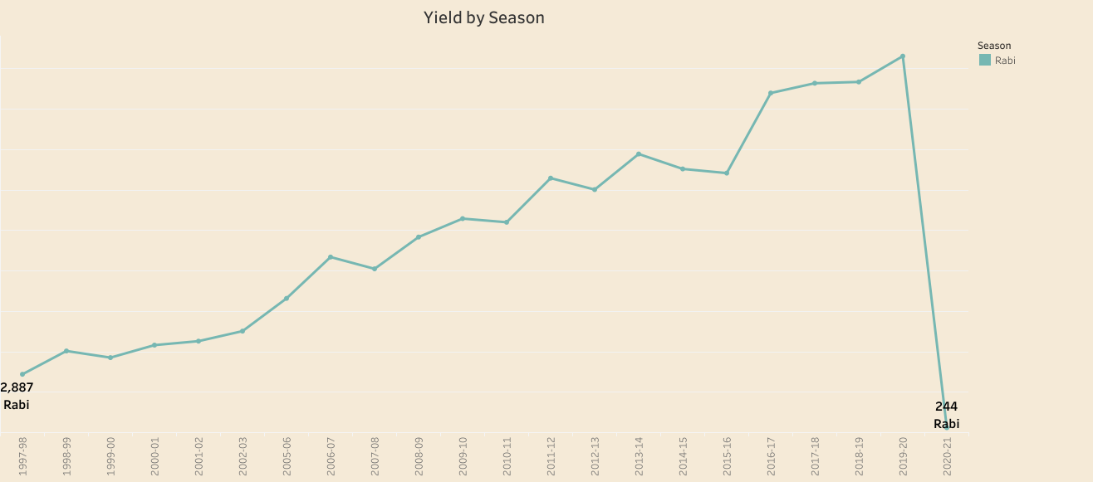

Activity 8:

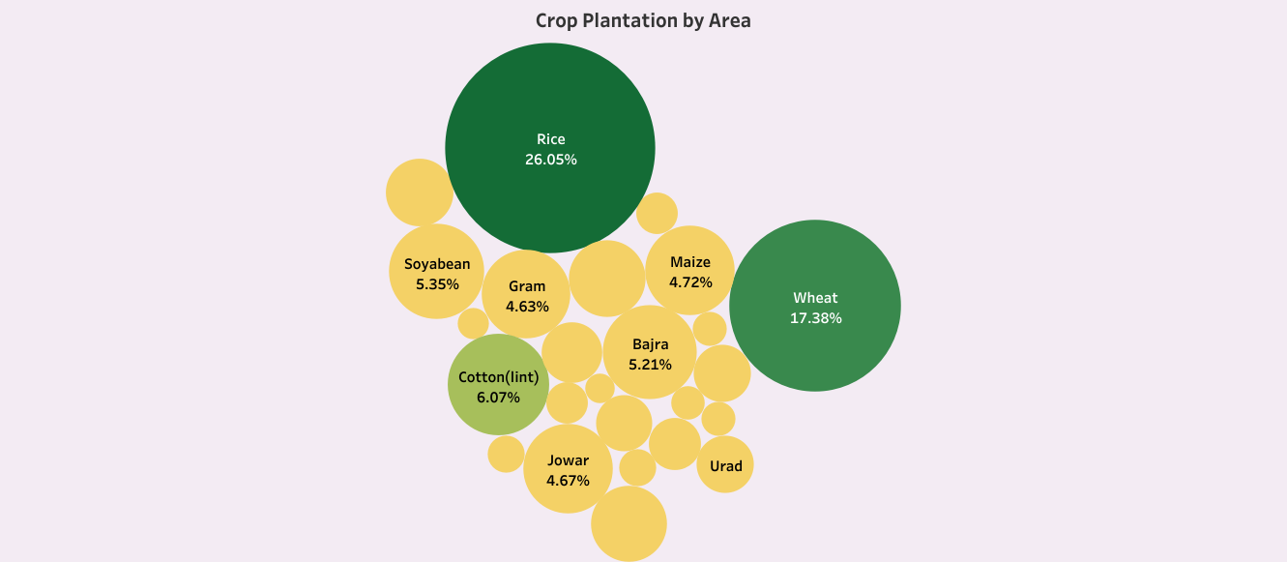

Activity 9:

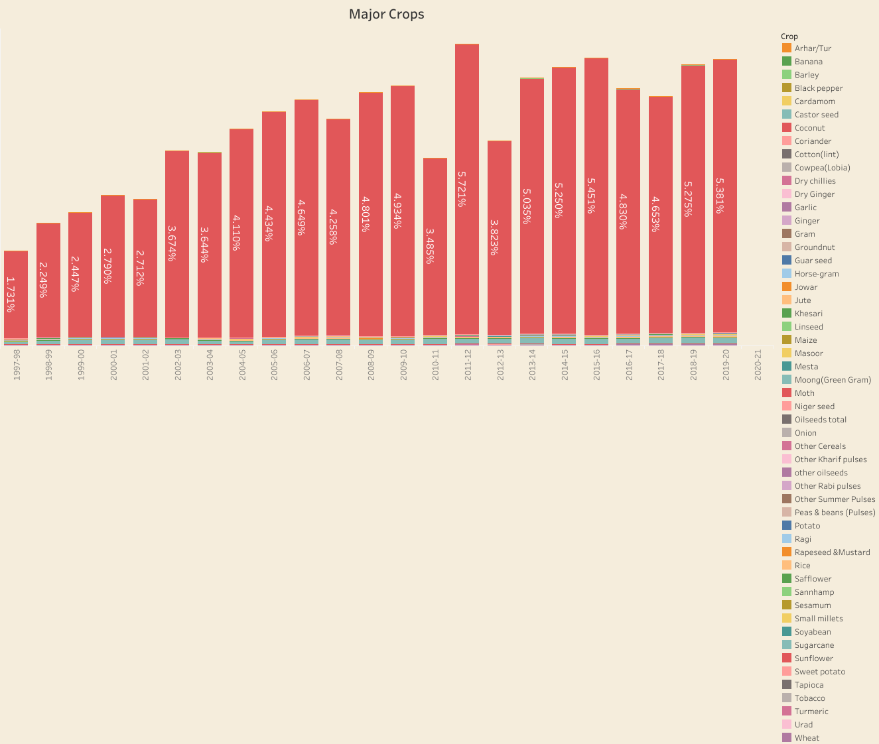



Activity 10:

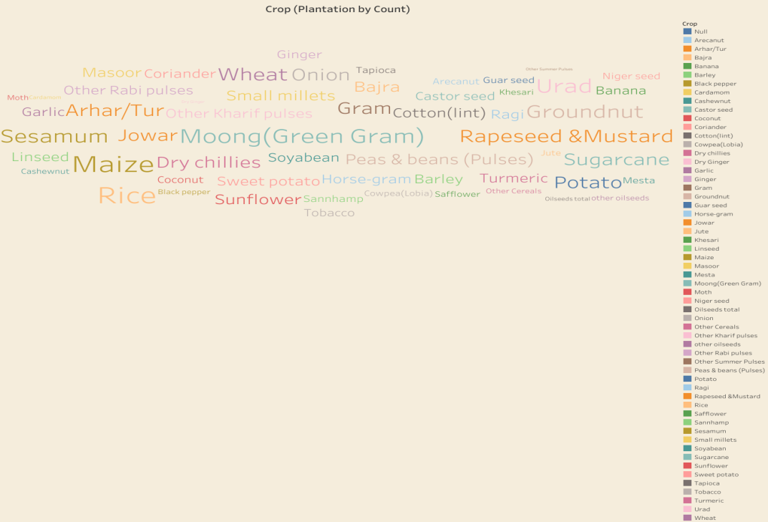

Activity 11:

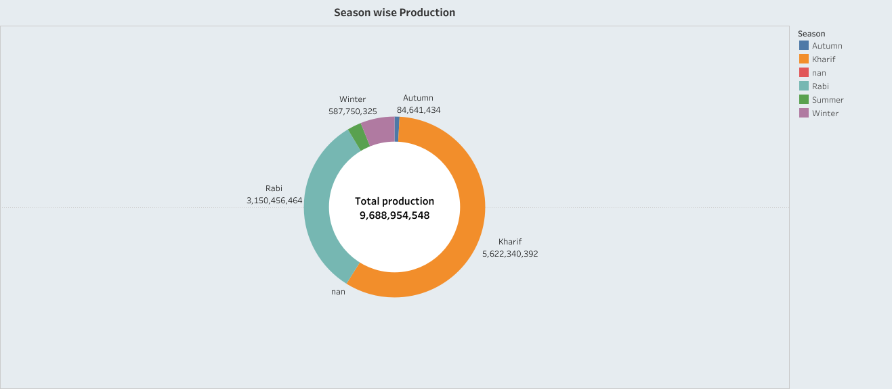

Dashboard 1:

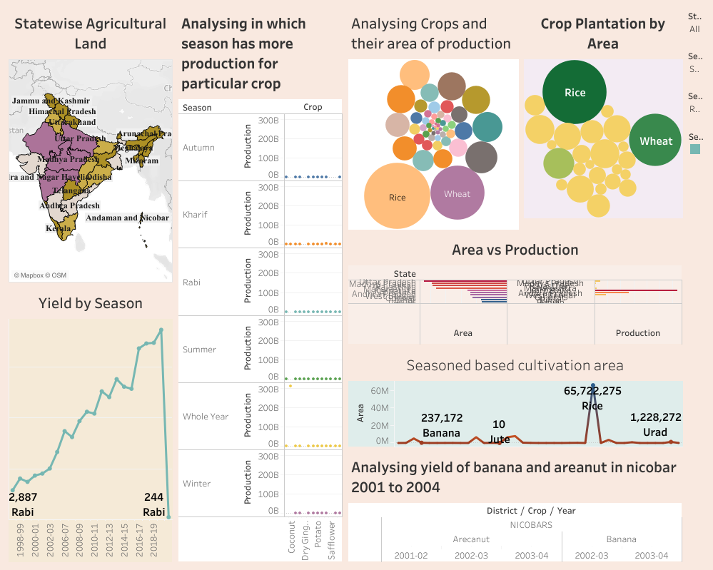

Dashboard 2:

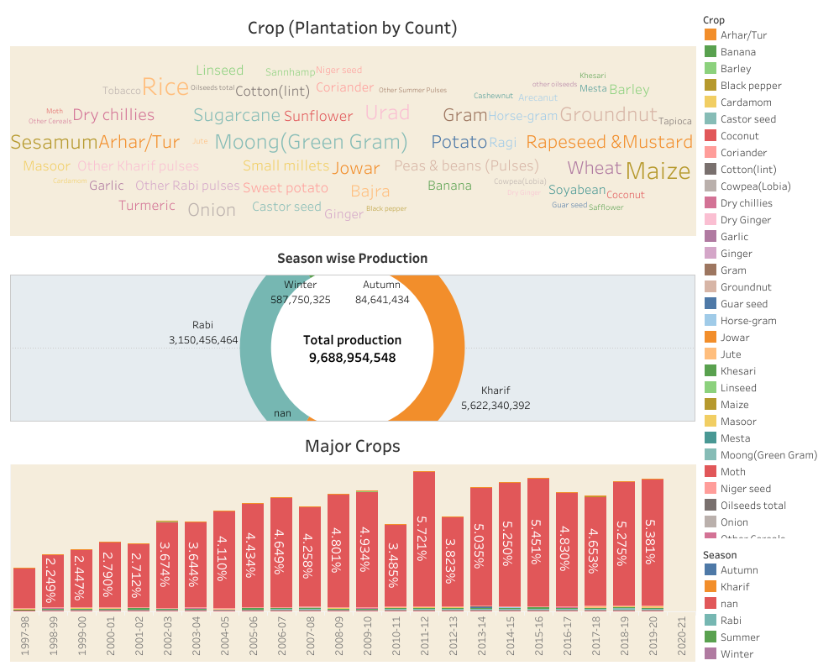

Dashboard 3:

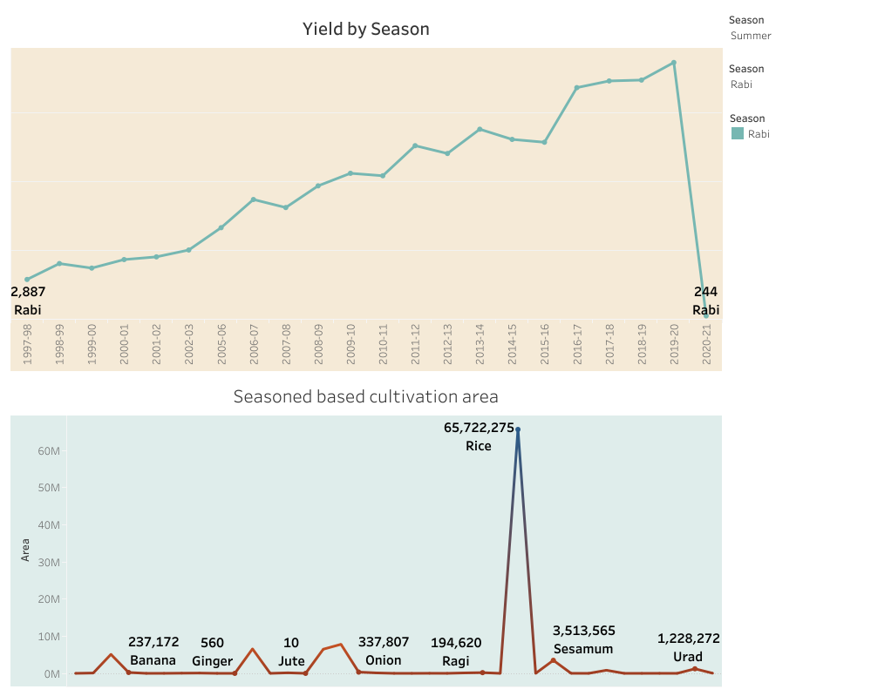

Story:

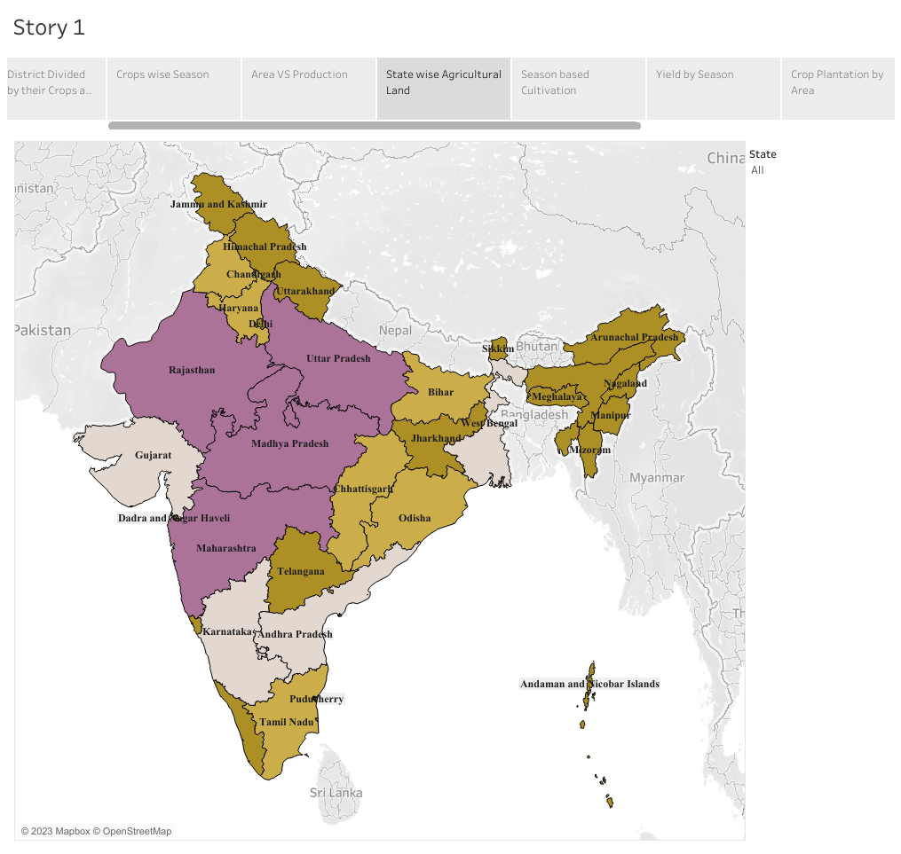

**ADVANTAGES & DISADVANTAGES:**

The main advantage of this project is that we can improve the the yields, profit of agriculture and reduce by collecting various information about Indian agriculture.

**APPLICATIONS**

Social Impact: On the social front, agriculture serves as a vital source of livelihood for a large portion of the population, especially in rural areas. It plays a crucial role in ensuring food security and alleviating poverty by providing employment opportunities and income generation. Moreover, agricultural activities contribute to the overall socio-economic development of rural communities, fostering social cohesion and preserving cultural traditions.

Business Impact: From a business perspective, the agricultural sector plays a pivotal role in India's economy. It contributes to the country's GDP and serves as a source of raw materials for various industries, such as food processing, textile, and pharmaceuticals. The growth and productivity of the agricultural sector have direct implications for the overall economic performance and stability of the nation. Furthermore, advancements in agricultural practices and technology have the potential to enhance productivity, optimize resource utilization, and promote sustainable practices. This, in turn, can lead to increased profitability and competitiveness for agricultural businesses.

**CONCLUSION**

In this project, we have analyzed the yearly production each crops in state wise, yield of each crops by state wise and season based crops.

**FUTURE SCOPE**

In future, we can extend our analysis to improve the yields, profit of agriculture and reduce by collecting various information about Indian agriculture.